**Unit 3 Physics**

**Circular Motion, Gravity & Equilibrium Test**

**2023**

Mark:

/54

Suggested Time 55 minutes

Weighting 5%

INSTRUCTIONS TO CANDIDATES

* Answer all questions in the spaces provided.
* All numerical answers must be evaluated and not left in fractional form.
* Give numerical answers to three significant figures, however estimates should be given to a maximum of two significant figures.
* Credit may be obtained for method and working out despite an incorrect final answer, **providing your solution to the problem is clearly set out**.



1. You’ve crash landed on the planet Principia. Prior to crashing, you had been tasked with taking certain readings of the planet, so you decide to pass the time by attempting to make the necessary measurements.
   1. You have a 500 g mass and a timer. By standing on top of your ship, you’re able to repeatedly drop the mass from a height of *exactly* 10.0 m, getting an average drop-time of 2.02 s. Calculate gravitational field strength on the surface of planet Principia:

(3 marks)

1 mark for working

$$s=ut+\frac{1}{2}at^{2};u=0 → a=\frac{2s}{t^{2}}$$

1 mark for units (not m/s2)

1 mark for answer

* 1. Sketch field lines below to indicate how the gravitational field strength of planet Principia compares to that of Earth (if you couldn’t answer part a., assume gravitational field strength on Principia is 5.00 N/kg):

(3 marks)

(Lines perpendicular to planet surface, Earth has twice the number of lines Principia has, lines are evenly spaced and do not overlap – deduct 1 mark for fewer than 3 lines on either diagram)





**Earth**

**Principia**

* 1. You’re able to calculate the planet radius as 3.48 x 106 m. Use this information to calculate the mass of planet Principia:

(2 marks)

✓

$$g=\frac{GM}{r^{2}}→M=\frac{gr^{2}}{G}$$

✓

$$M=\frac{4.90{\left(3.48×{10}^{6}\right)}^{2}}{6.67×{10}^{-11}}=8.90×{10}^{23} kg$$

$$*9.08×{10}^{23} kg if they used g=5.00 m/s^{2}$$

1. The following roller-coaster ride is entirely gravity-driven and frictionless; the cart is allowed to roll from a height ‘h’ above the ground without any form of power, gathering enough speed to pass through the loop without falling from the track.

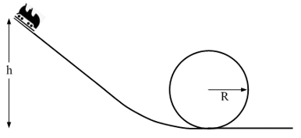

The radius of the loop is 6.00 m. The mass of the cart, with passengers, is 1150 kg. The initial velocity, at the top of the track, is 0 m/s.

* 1. With reference to the forces involved, state the condition required to ensure that the cart *just* remains in contact with the track at the top of the loop.

(1 mark)

The centripetal force must be provided entirely by gravity/weight force (or centripetal force = weight force, or normal force = 0).

* 1. Calculate the minimum speed required at the top of the loop to ensure that the cart *just* remains in contact with the track.

(2 marks)

✓

✓

* 1. Find the minimum height ‘h’ from which the cart can be released to ensure the cart reaches this minimum speed at the top of the loop (use v = 7.70 m/s if you couldn’t solve b.).

(3 marks)

✓

✓

✓

* 1. Find the magnitude of the normal force on the cart at the bottom of the loop.

(4 marks)

✓

$$E_{K}=1.69×{10}^{5}$$

✓

$$E_{K}=\frac{1}{2}mv^{2}→v=\sqrt{\frac{2E}{m}}=\sqrt{\frac{2(1.69×{10}^{5})}{1150}}=17.15 m/s$$

✓

✓

$$F_{N}=F_{C}+F_{W}$$

$$m\left(\frac{v^{2}}{r}+g\right)=1150\left(\frac{{17.15}^{2}}{6}+9.8\right)=6.76×{10}^{4} N$$

1. Hugh and Greg are sitting on a see-saw; Hugh has a mass of 40 kg, whereas Greg has a mass of 60 kg. Given that Greg is sitting 1.50 m from the fulcrum, determine the following:

(3 marks)

* 1. The force exerted by the fulcrum on the see-saw beam:

✓

* 1. How far from the fulcrum Hugh must sit to balance with Greg:

✓

$$\sum{τ_{cw}}=\sum{τ_{acw}} , τ=Fr̝$$

✓

$$\left(40×9.8\right)×r=\left(60×9.8\right)×1.50→r=2.25 m$$

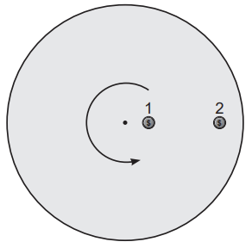

1. Two identical 20.0 g coins are placed on a rotating disc, 0.35 m and 1.40 m respectively from the centre of the disc. The disc begins to rotate. When the frequency of rotation reaches 3.00 Hz, the outer coin flies off the disc. Calculate the frequency of rotation when the inner coin flies off

(5 marks)

*Find speed v2:

✓

*Centripetal force is provided by friction.

✓

$$F_{F}=F_{C}=\frac{mv_{2}^{2}}{r_{2}}=\frac{(20×{10}^{-3}){\left(26.4\right)}^{2}}{1.40}=9.95 N$$

*Find speed v1:

✓

✓

*Find frequency f1:

✓

*\*\*Other approaches are possible, award marks for valid approach.*

1. A satellite in a Medium-Earth Orbit (approximately 20000 km orbital radius) is moved to a geosynchronous orbit:
   1. Find the orbital radius for a geosynchronous satellite:

(3 marks)

✓

Τ = 24 hours = 24 x 60 x 60 = 86400 s

*Kepler’s 3rd Law:

✓

✓

* 1. The graph below shows how the gravitational force on the satellite changes with increasing orbital radius. Using this graph, and your answer to part a., estimate the work done to get the satellite from Medium-Earth Orbit into geosynchronous orbit (if you couldn’t get the answer to part a., assume r = 4.30 x 107 m).

(5 marks)

✓

$$Area of 1 box=50×2×{10}^{6}=1×{10}^{8} J$$

✓✓

$$I count roughly equivalent to 21 boxes in bounded area \left(accept 20\sim 22\right), also correct bounds$$

✓

$$21×1×{10}^{8}=2.1×{10}^{9} J$$

✓

$$*Estimate=2 sig. figs. for answer.$$

1. 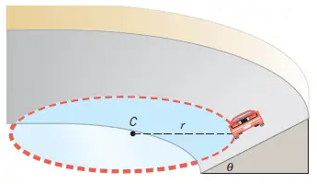A 950 kg vehicle is traversing a curve or radius 30.0 m, banked at an angle of 40⁰ to the horizontal.
   1. Derive an expression for the speed at which the vehicle can traverse the curve without relying on friction, and evaluate this expression. Include any relevant diagram(s):

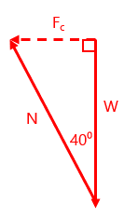(4 marks)

✓

✓

✓

✓

* 1. Find the magnitude of the normal force acting on the vehicle:

(2 marks)

✓

$$W=950×9.8=9310 N$$

✓

$$N=\frac{W}{\cos{40°}}=\frac{9310}{\cos{40°}}=12153.34 N=1.22×{10}^{4}N$$

*\*Students could also find FC first and solve for N – accept this approach if working is valid.*

* 1. The driver is in a rush and takes the curve at a speed of 25.0 m/s. State the effect this will have on the magnitude of *each* of the forces involved.

(4 marks)

✓

Weight force will be unaffected.

✓

Centripetal force will increase in magnitude (due to v increasing, Fc = mv2/r).

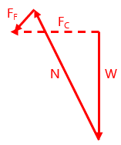Vehicle will now need to rely on a friction force. (Friction force will be directed down the slope).

✓

✓

The Normal force will increase in magnitude. (Both to increase the horizontal contribution to Fc and to cancel the vertical component of the new Friction force).

*\*Diagram not necessary, but is included here for clarity.*

*\*Marks awarded for underlined statements only in the above text.*

1. A 6.0 m uniform beam of mass 25 kg is suspended by a cable. An 85 kg object hangs from one end. Calculate the tension in the cable and the reaction force of the wall on the beam.

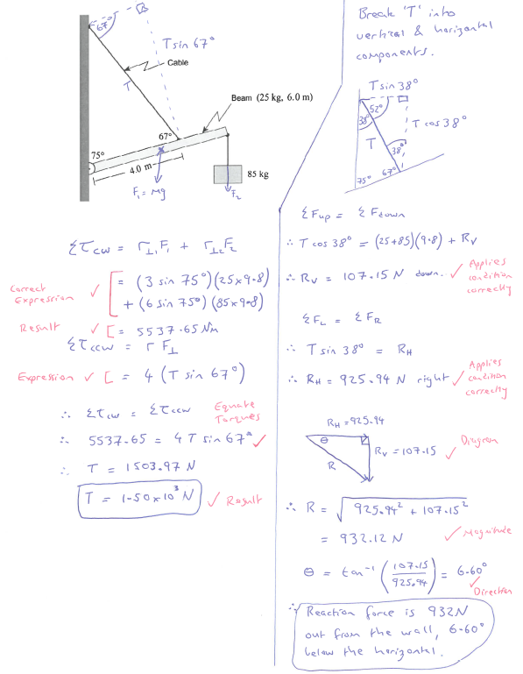(10 marks)

Spare Page:

**End of Test**